IFG Explore 2nd Year

Term Four - Week Six Fire Spiritual / Interest

Aim:
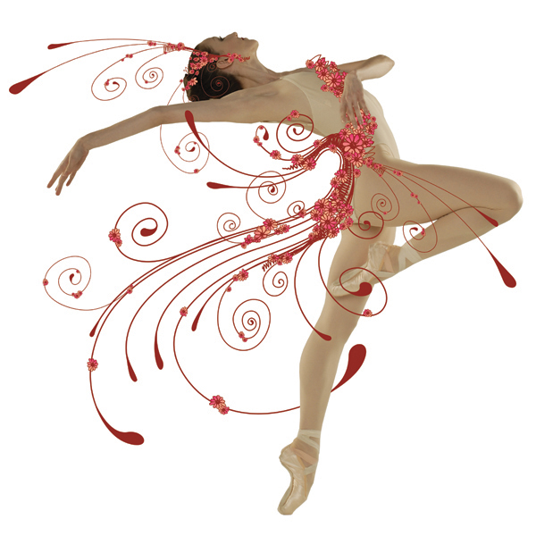
During this term we will complete the year’s programme on elements by focusing on the fourth and final element – fire.

Objectives:
During this term we will:
- Learn about fire, its uses and misuses and about fire safety
- Learn a dance to perform for guest at the Final Fling (last session for the year)
- Construct costumes to wear in the dance
- Prepare refreshments to serve at the Final Fling
- Look at some of places in the Bible where fire is mentioned

Pre Setup:
Prepare whatever is required to continue practicing the dance and making the costumes.
Gather together ingredients to make refreshments for Final Fling

SetUp:
Commence the formal part of the session with roll call etc.

Devotions:
Today’s verse is from Acts Chapter 28 verse 2. (Saint Paul has landed on the island of Malta).
“The islanders showed us unusual kindness. They built a fire and welcomed us all because it was cold and raining”.
It is a good thing to show hospitality. Tonight we will be looking at what we will be doing next week to welcome our guests – how can we make them feel welcome?
Greeting them warmly and smiling.
Showing them to their seats.
Checking that no one is sitting on their own
Providing entertainment (our dance)
Giving them something to eat and drink.

Pray for next week. That the girls will not be nervous during their performance and that everyone will have a very enjoyable evening.

Activities:
Have a full dress rehearsal.

Sort out the refreshments for next week’s “An afternoon/evening at the ballet”.
Suggestions:

- Drink – Sugar Plum Fairies. A pink fluffy.
- Nibbles – Nutcracker Sweets. Walnut fudge.
- Choux pastry swans – Swan Lake. You will find how to make these on Youtube but will be a little too complicated for girls of this age. Here is where you can enlist the help of your church’s ladies group.

Hand out reminder notices about the Final Fling next week – “An afternoon/evening at the Ballet”, and give any other notices.

Closing prayer.

Home Time

